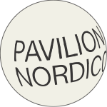
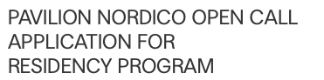

General Information

Name of individual(s):

Name of group/collective/organisation (if applicable):

Birthdate(s):

Nationality:

Address:

Email:

Telephone:

Website / Social Media:

QUESTIONS FOR PUBLIC PROGRAM PROJECT PROPOSALS

Why would you like to take part in the PAVILION NORDICO
residency program?
Type to enter text (1000 words)
Type to enter text (1000 words)
What would you like to work on during your stay?
Type to enter text (1000 words)

How would you like to engage with the local community in Buenos Aires?
Type to enter text (1000 words)
Preferred Residency Period

Please write down your preferred residency period. Residencies can last up to 1 month between March 1st and Dec 30th 2019. You can write up to 3 different periods..
Type to enter text

Further Information

Do you wish to be considered for a travel grant? (set an X)
Yes No

Are you applying for one of the special-interest areas? (set an X)
Yes No

If so, which one?

Do you have any special needs or restrictions?

How did you learn about PAVILION NORDICO?

